GRADE 7 ACCELERATED · UNIT 1 · LESSON 2
Repeating Decimals to Fractions
Worksheet 7A.01.02 ANSWER KEY

Use the repeating decimal 0.232323… for questions 1 through 4.
1. Let x = 0.232323… Complete each equation.
 | 10x | = 

 | 100x | = 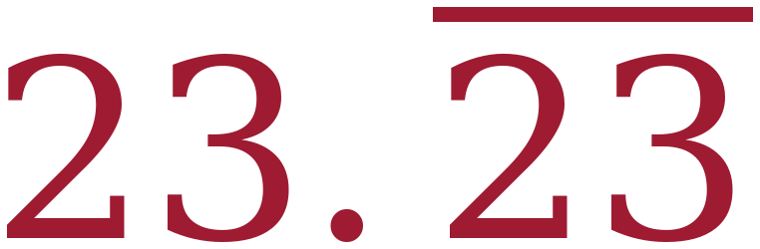
Multiplying by 10 moves the decimal point one place: 10 × 0.232323… = 2.323232… Multiplying by 100 moves it two places, which lines the repeating tails up with the original.
2. Which two values, when subtracted, leave a whole number? Fill in one bubble.
○ 10x and x
● 100x and x
○ 100x and 10x
Two digits repeat, so 100x is the multiplier that lines the tails up. 23.232323… − 0.232323… leaves a whole number.
3. Use two of the equations from question 1 to find the fraction equivalent of 0.232323… Show the subtraction step.
100x − x = 23.232323… − 0.232323…
99x = 23
x = 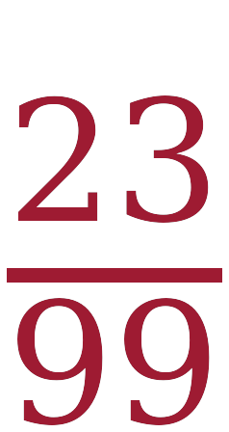
23/99 will not simplify — 99 = 9 × 11 and 23 is prime.
4. Write 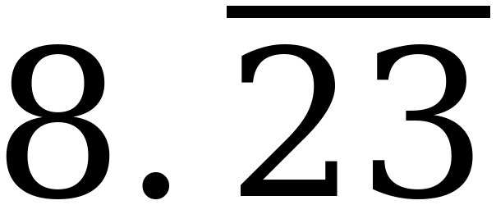 as a fraction and as a mixed number.
Fraction: 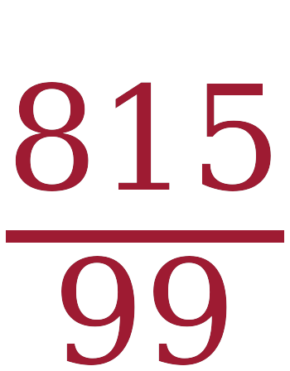 Mixed number: 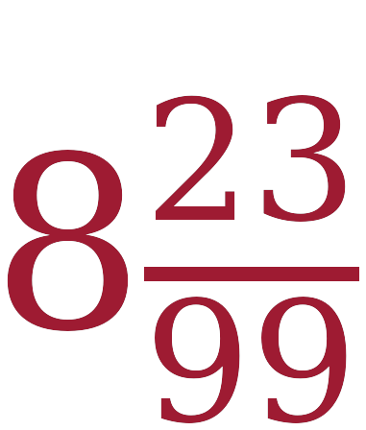
The decimal part is the 23/99 from question 3. Then 8 × 99 + 23 = 815.

A trail mix recipe uses these amounts: raisins 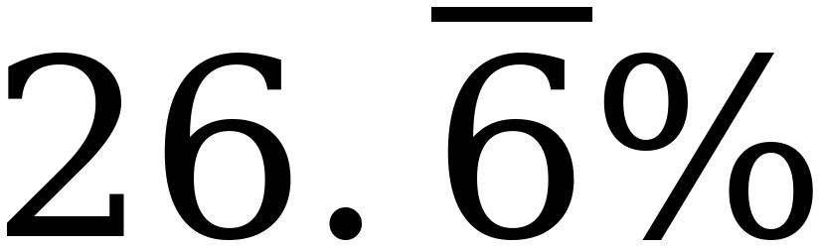, peanuts 3/8, chocolate chips 0.09, and the rest is chex mix.
The bar means the 6 repeats forever.

5. What fraction of the recipe is chocolate chips?
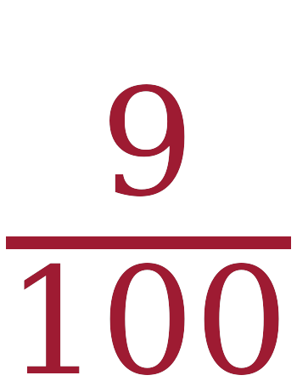
0.09 has its last digit in the hundredths place.
6. What fraction of the recipe is raisins?

= 0.26666… Then 100x − 10x gives 90x = 24, so x = 24/90 = 4/15.
7. What is the decimal equivalent of the peanuts?
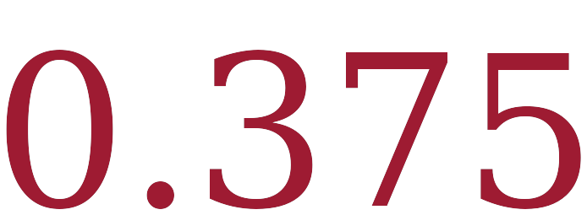
3 ÷ 8 = 0.375 exactly.
8. About what percent of the recipe is chex mix? Round to the nearest whole percent.
27%
Over 600ths: 4/15 = 160/600, 3/8 = 225/600 and 9/100 = 54/600, which total 439/600. Then 600 − 439 = 161, and 161 ÷ 600 = 0.26833…, which rounds to 27%.
For questions 9 and 10, complete the table.
 | Decimal | Percent | Fraction or Mixed Number
9. | 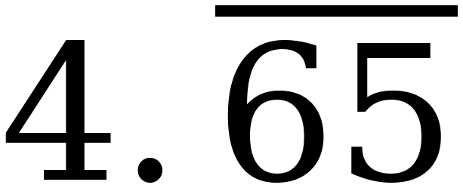 | 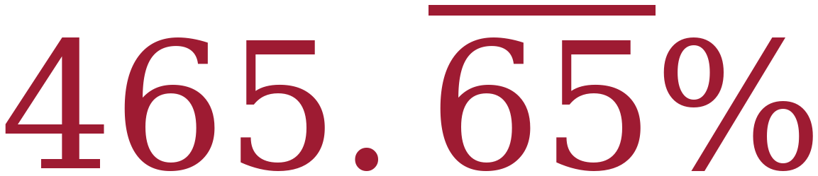 | 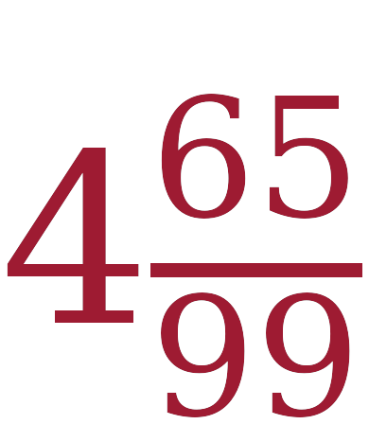
10. | 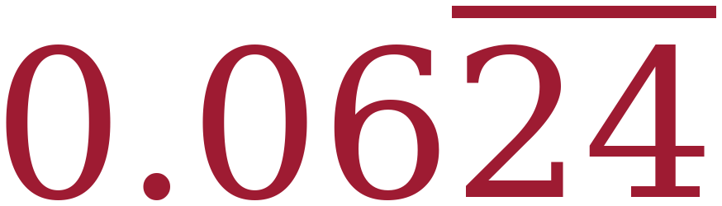 | 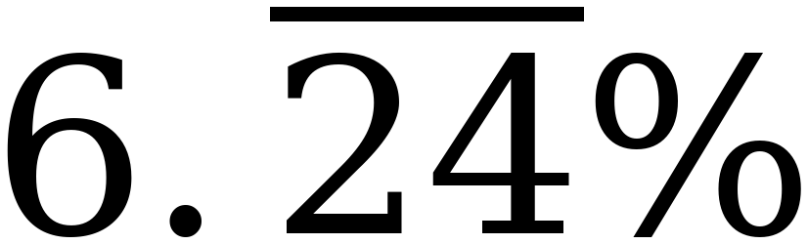 | 
9) Move the decimal two places right for the percent. For the fraction, 100x − x gives 99x = 461, so x = 461/99 = 4 65/99.
10) Clear the repeat first: 100x − x on 6.242424… gives 99x = 618, so 6.242424… = 618/99 = 206/33. A percent is out of 100, so divide by 100 at the end: 206/3300 = 103/1650.

